
AI-Enhanced Puzzle Game MindShift


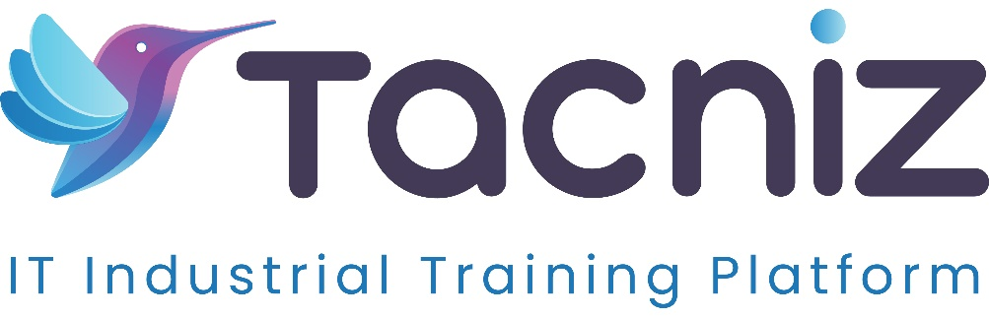

Problem Statement
Traditional puzzle games often have fixed levels of difficulty, which can either frustrate players when levels are too challenging or bore them when levels are too easy. This lack of adaptability can lead to reduced engagement and satisfaction. MindShift, an AI-enhanced puzzle game, addresses this issue by dynamically adjusting the difficulty based on the player’s performance. By analyzing the player’s skills and progress, the game adapts the complexity of each level, creating a personalized and engaging experience that keeps players motivated and challenged.

Project Type
- Type: 2D Puzzle Game with AI Adaptability
- Category: Gaming, Artificial Intelligence, Entertainment

Industry Area
- Industry: Gaming, Artificial Intelligence, Entertainment
- Relevant Sectors: Mobile and PC Gaming, Casual Gaming, Game Development, Interactive Entertainment

Software Expertise Required
Developing an AI-enhanced puzzle game like MindShift requires expertise in various technical and creative areas:
- Game Development: Proficiency in game development engines such as Unity or Godot, which allow for 2D game design and implementation of interactive puzzle elements.
- Artificial Intelligence for Adaptive Difficulty: Skills in AI and machine learning algorithms to dynamically adjust difficulty levels based on player performance and play style.
- Data Analytics for Real-Time Adaptation: Knowledge of data analytics to analyze player behavior in real-time, informing the AI about when to increase or decrease puzzle complexity.
- UI/UX Design for Games: Expertise in game interface and user experience design to create an intuitive, visually appealing layout that is both engaging and easy to navigate.
- Graphics and Animation for 2D Art: Experience in 2D art and animation tools, such as Adobe Illustrator or Spine, for designing visually appealing and fluid game graphics.
- Backend Development and Database Management: Skills in backend frameworks like Node.js or Django and databases like MongoDB or Firebase to manage player data, game states, and progress.
- Game Testing and Optimization: Knowledge of game testing techniques and tools to ensure a smooth, optimized gaming experience across different devices and platforms.

Key Features
- AI-Driven Adaptive Difficulty: The game’s AI tracks player performance and adapts the difficulty of puzzles in real-time. This feature personalizes the experience by adjusting challenges to keep players engaged without causing frustration.
- Dynamic Puzzle Progression: As players advance, they encounter increasingly complex puzzles that test logic, pattern recognition, and strategic thinking, with rewards based on efficiency and creativity.
- Personalized Play Style Analysis: The AI identifies each player’s unique play style, modifying puzzles to match their strengths or challenge their weaknesses, enhancing skill development and engagement.
- Reward System for Efficiency: Players earn rewards, such as points or in-game items, based on how efficiently they solve puzzles, motivating them to improve their skills and complete levels faster.
- Progress Tracking and Analytics: Players can view insights on their progress, including levels completed, time taken, and puzzle-solving efficiency, helping them track their improvement over time.
- Visually Engaging 2D Graphics: MindShift features a sleek, minimalistic design with captivating animations, making gameplay both mentally stimulating and visually enjoyable.

Use Cases
- For Casual Gamers: The AI-driven adaptability appeals to casual gamers who want a puzzle game that meets their skill level and keeps them engaged without becoming overwhelming.
- For Puzzle Enthusiasts: MindShift offers puzzle lovers a platform where they can tackle unique challenges that adapt to their abilities, providing a constant, personalized test of logic and strategy.
- For Educational Institutions: The game’s adaptive learning approach makes it suitable for schools and educational programs looking to engage students in logic-based learning and critical thinking exercises.
- For Mindfulness and Brain Training: MindShift can be used as a brain-training tool to improve focus, logic, and problem-solving skills, appealing to users who want to enhance cognitive functions in a fun way.

Expected Outcomes
MindShift will create a unique puzzle gaming experience by incorporating AI to adjust difficulty based on each player’s progress and play style. This adaptation keeps players engaged longer, providing a tailored challenge that suits all skill levels. The game will appeal to both casual and dedicated players, enhancing cognitive skills and providing an enjoyable way to exercise logic and problem-solving abilities. The AI-based adaptability sets MindShift apart from traditional puzzle games, making it a refreshing and personalized experience for every player.

Benefits
- Enhanced Player Engagement: By adjusting difficulty based on performance, the game keeps players consistently engaged, reducing the risk of boredom or frustration.
- Improved Cognitive Skills: MindShift helps players develop critical thinking, logic, and problem-solving abilities through progressively challenging puzzles.
- Personalized Gaming Experience: Each player’s journey through the game is unique, with the AI customizing the experience to match their abilities and preferences.
- Increased Replay Value: The adaptive nature of the game encourages players to return, knowing that they’ll face new challenges each time they play.
- Progressive Skill Development: As the game tailors its challenges to player performance, it supports gradual skill improvement and cognitive growth over time.
- Immersive and Visually Appealing Gameplay: The minimalistic design, coupled with smooth animations, creates a visually enjoyable experience that enhances immersion.

Project Duration
- Estimated Duration: 5-6 months for development, testing, and deployment, including time for refining the AI adaptability, designing puzzles, and creating a user-friendly interface.

